**Application of Large Scale Gas Electron Multiplier Technology to Digital Hadron Calorimetry.**

A. P. White, J. Yu, S. Park

University of Texas at Arlington, Arlington, TX 76019

The High Energy Physics group at UTA has been developing a new type of calorimetry, based on the Particle Flow technique, for experiments at the future International Linear Collider. White proposed the application of GEM [1] technology to digital hadron calorimetry. Basic requirements include, the ability to achieve a high level of transverse and longitudinal segmentation, a MIP signal well separated from the noise level, a high density front-end readout to handle the large number of channels, and flexibility in the design and implementation of a variety of active layer sizes in realistic size modules. GEM technology offers a viable and attractive solution to these requirements. Our proposed digital hadron calorimeter (Fig. 1) comprises a stack of steel absorbers, of sufficient thickness to contain hadronic showers, interlaced with active gaseous sampling-elements.

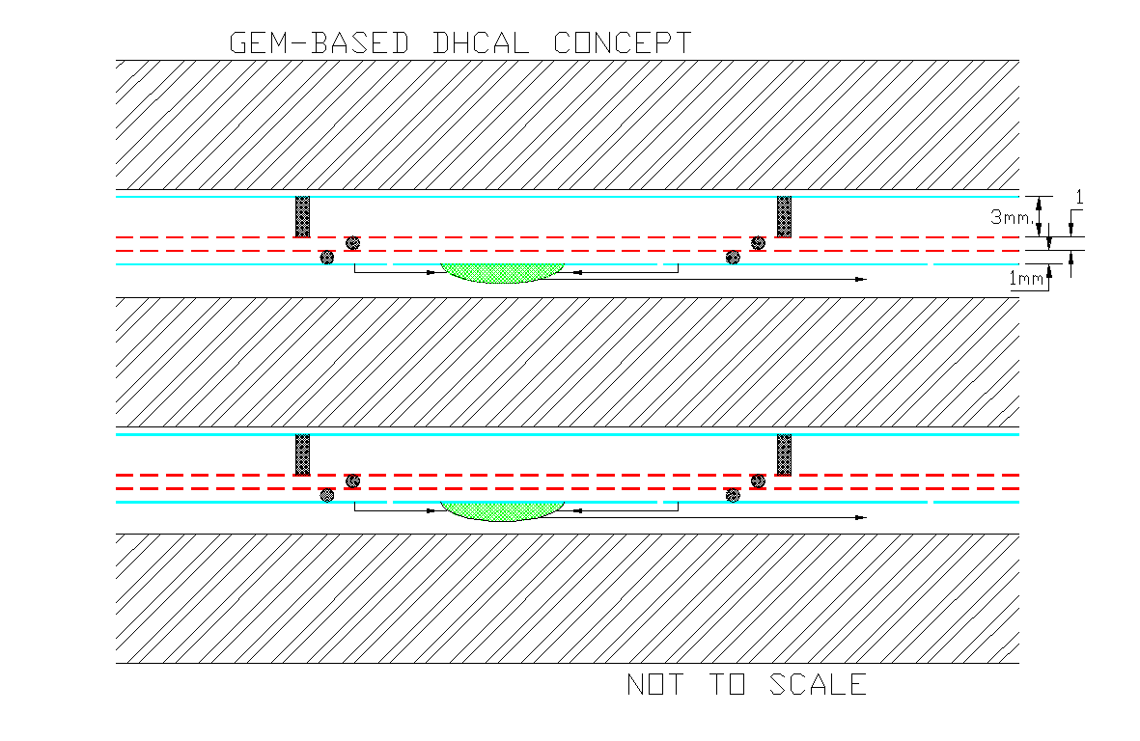 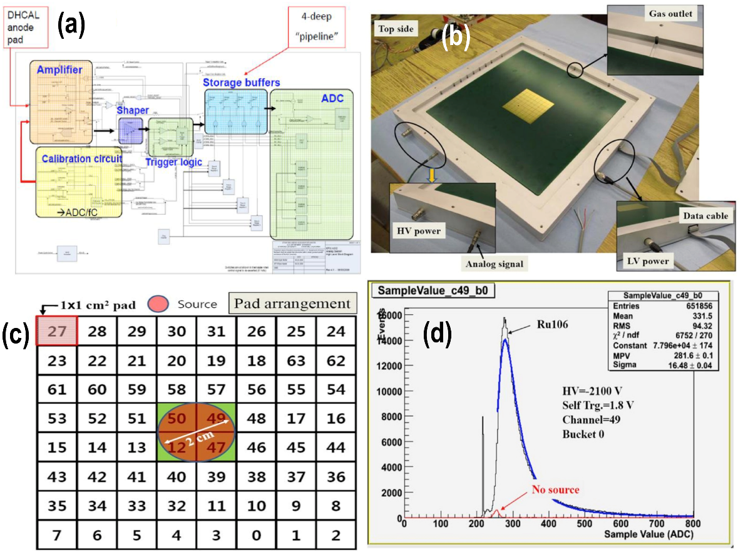

**Fig 1. Concept for a Digital Hadron GEM-based Calorimeter Fig 2. Initial GEM-DHCAL prototype**

A series of prototype detectors (Fig 2.) has already been constructed and tested using 10cm x 10cm GEM-foils from CERN and 30cm x 30cm GEM-foils from 3M Corporation and CERN [2]. The KPiX chip from SLAC was used for the readout. KPiX has a four-deep pipeline, on-board DAC charge injection calibration, and a Wilkinson 13-bit ADC for each of its 1024 channels. Results from exposure to cosmic rays, and an external, scintillator trigger, yielded MIP detection efficiency of 95%, in agreement with simulation predictions. The corresponding hit multiplicity, the average number of hits seen in a single active layer when one particle passes through, was measured to be 1.7 (Fig 3.).

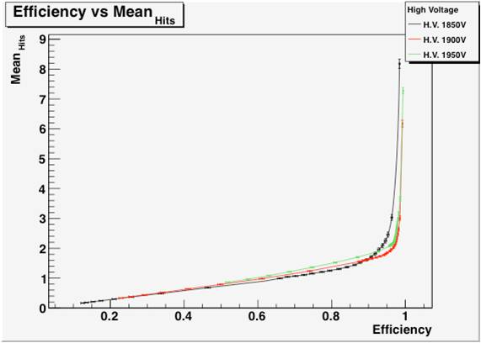 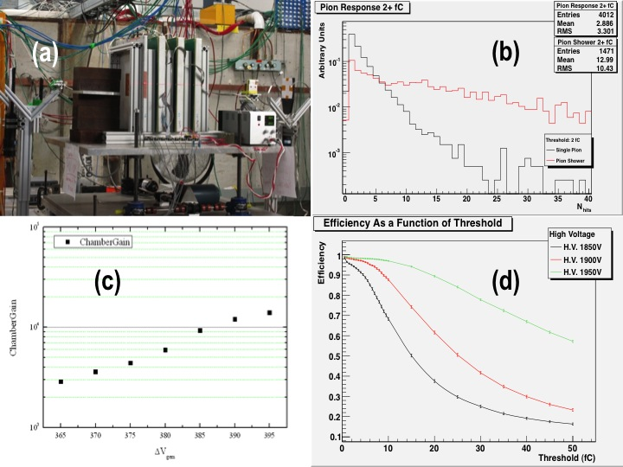 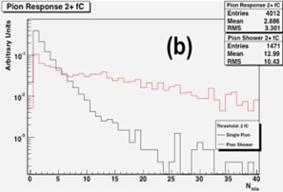

**Fig 3. Hit multiplicity vs. efficiency Fig 4. (left) GEM chamber stack Fig 5. Pion beam (single/showers)**

This predicts only little confusion in track following and energy cluster definition in a final calorimeter system. A gas mixture of Argon 80%, CO2 20% was used throughout these initial studies, and for which a most probable signal size of 10 fC was measured for a MIP. The detector gain was about 3,500. Various chambers (Fig 4.) were also exposed to a test beam at Fermilab, with satisfactory stable performance for single pions (non-interacting) and showers induced by steel absorber in front of the chambers [3].

**Engineering challenges**

CERN has demonstrated that large area GEM foils can be successfully produced using the single-side etching technique. This technology would need to be available from a commercial manufacturer for large quantity production. The main challenges would then be the assembly of many different size double-GEM chambers, for the 40 layers of a DHCAL, the longitudinal division of the barrel chambers, with solutions to the provision of high voltage and gas through multiple chambers and the extraction/readout of the signals from the large number of small pads.

**Detector R&D Plans for the coming years**

The next stage in the development of GEM-based DHCAL is the construction of large area chambers. We have received and qualified five  large GEM foils. We are developing the mechanical structure, the electronic readout board schemes and the schemes for integrating the three unit chambers () into one  plane (Fig 6.). We plan to construct and test two of these unit chambers initially.

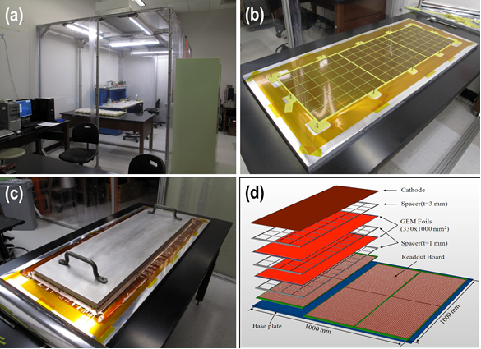

**Fig 6. Large scale GEM chamber activity at UTA: (a) Purpose-built clean room for handling large foils,**

**(b) partially assembled 33cm x 100cm double-GEM chamber, (c) glue curing stage under pressure plate,**

**(d) schematic view of three 33cm x 100cm chambers integrated in a 1m2 chamber.**

Work on the large chambers is currently waiting the resumption of support for ILC detector activities in the U.S.

**Perspectives for applications beyond the ILC**

This technology is already being used in many areas of application: CMS forward chambers, planar chambers for TOTEM, and even in cylindrical geometries. Beyond HEP, GEM technology is used in many in many human and animal medical imaging systems, and in muon tomography for homeland security. Many applications can be found at the CERN RD51 web site and links to RD51 meetings therein [4].

[1] F. Sauli, GEM: A new concept for electron amplification in gas detectors, [Nucl. Instr. and Meth. A386(1977)531](http://gdd.web.cern.ch/GDD/publications.res/NIMA386%281997%29531.pdf).

[2] White, A, J. Yu, and S. Park (2012), Development of a gas electron multiplier-based digital hadron calorimeter," J.Phys.Conf.Ser. 404, 012031.

[3] For a more detailed report see: A.White, “Digital Hadron Calorimetry using Gas Electron Multipliers”, SiD Workshop at SLAC 2015, <https://agenda.linearcollider.org/event/6522/>.

[4] <http://rd51-public.web.cern.ch/RD51-Public/Welcome.html>